**Технические параметры компьютера:**

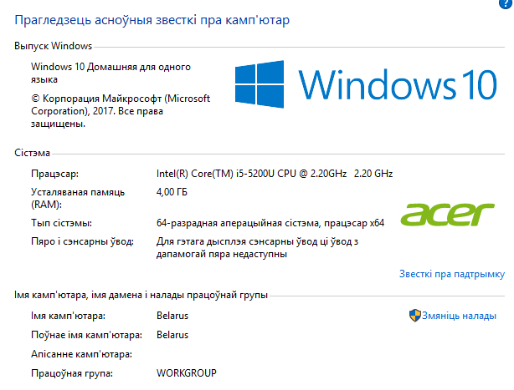

**Результаты работы программы:**

|  |  |  |  |  |  |  |  |  |  |  |  |  |  |  |
| --- | --- | --- | --- | --- | --- | --- | --- | --- | --- | --- | --- | --- | --- | --- |
| Test | 1 | 2 | 3 | 4 | 5 | 6 | 7 | 8 | 9 | 10 | 11 | 12 | 13 | 14 |
| |I| | 50 | 50 | 50 | 100 | 100 | 100 | 150 | 150 | 150 | 150 | 200 | 200 | 200 | 200 |
| |U| | 200 | 500 | 1000 | 500 | 1000 | 2000 | 500 | 1000 | 2000 | 4000 | 500 | 1000 | 2000 | 4000 |
| 1. | $$0.1529394$$ | $$0.1750296$$ | $$0.2144534$$ | $$0.1940744$$ | $$0.2371707$$ | $$0.3192458$$ | $$0.2047808$$ | $$0.23684$$ | $$0.3335216$$ | $$0.2812537$$ | $$0.1847209$$ | $$0.2343814$$ | $$0.2968784$$ | $$0.323425$$ |
| 2. | $$0.0520346$$ | $$0.045031$$ | $$0.0705508$$ | $$0.078556$$ | $$0.0905669$$ | $$0.0895494$$ | $$0.0965693$$ | $$0.0905482$$ | $$0.1205858$$ | $$0.1718679$$ | $$0.0937351$$ | $$0.1093761$$ | $$0.1249941$$ | $$0.2656189$$ |
| 3. | $$0.237167$$ | $$0.6529634$$ | $$1.2033542$$ | $$1.0412092$$ | $$2.3621807$$ | $$4.9089825$$ | $$1.1562457$$ | $$2.8915538$$ | $$7.9066438$$ | $$13.990674$$ | $$1.2690059$$ | $$3.5726985$$ | $$8.4697732$$ | $$16.8291775$$ |
| 4. | $$0.1506086$$ | $$0.1646176$$ | $$0.2287088$$ | $$0.1571096$$ | $$0.2441734$$ | $$0.3567433$$ | $$0.1606147$$ | $$0.2196585$$ | $$0.2926922$$ | $$0.4995299$$ | $$0.1406411$$ | $$0.1890718$$ | $$0.2812664$$ | $$0.4547168$$ |
| 5. | $$0.380771$$ | $$1.0652627$$ | $$2.112353$$ | $$1.7808122$$ | $$3.4349382$$ | $$8.2821453$$ | $$1.9428858$$ | $$5.3623076$$ | $$12.307784$$ | $$22.8583843$$ | $$2.2172512$$ | $$5.5002331$$ | $$12.9504343$$ | $$27.4697508$$ |
| 6. | $$0.6639726$$ | $$1.9872399$$ | $$3.790211$$ | $$6.1894133$$ | $$11.346913$$ | $$28.9669364$$ | $$13.6567269$$ | $$27.4927009$$ | $$57.5523526$$ | $$97.8587794$$ | $$21.937552$$ | $$42.078333$$ | $$81.8450308$$ | $$163.2930697$$ |
| 7. | $$0.2806519$$ | $$0.3737811$$ | $$0.3102198$$ | $$0.2912068$$ | $$0.5776241$$ | $$1.2683995$$ | $$0.4388099$$ | $$1.1603241$$ | $$1.5058771$$ | $$2.6247909$$ | $$0.5781322$$ | $$1.2383278$$ | $$2.1877468$$ | $$5.1715978$$ |
| 8. | $$0.954175$$ | $$2.1145078$$ | $$3.8431311$$ | $$3.2446021$$ | $$6.3945399$$ | $$14.0454901$$ | $$3.5809902$$ | $$8.784021$$ | $$20.9947697$$ | $$37.7602227$$ | $$3.9081548$$ | $$9.5922537$$ | $$22.1858504$$ | $$45.2820604$$ |
|  |  |  |  |  |  |  |  |  |  |  |  |  |  |  |